**DAILY ONLINE ACTIVITIES SUMMARY**

|  |  |  |  |  |  |  |  |
| --- | --- | --- | --- | --- | --- | --- | --- |
| **Date:** | 07-07-2020 | | | | **Name:** | Gudugunti Anirudh | |
| **Sem & Sec** | IV A sec | | | | **USN:** | 4AL18CS023 | |
| **Online Test Summary** | | | | | | | |
| **Subject** | | ---- | | | | | |
| **Time limit** | | --- | | **Score** | | --- | |
| **Certification Course Summary** | | | | | | | |
| **Course** | C programming | | | | | | |
| **Certificate Provider** | | | Udemy | **Duration** | | | **11.5hr** |
| **Coding Challenges** | | | | | | | |
| **Problem Statement:**  1: program to find the Nth natural number with exactly two bits set | | | | | | | |
| **Status:** completed | | | | | | | |
| **Uploaded the report in Github** | | | | yes | | | |
| **If yes Repository name** | | | | | https://github.com/alvas-education-foundation/anirudh_gudugunti/tree/master/daily_progress | | --- | | | | |
| **Uploaded the report in slack** | | | | yes | | | |

**Online Test Details: Not conducted**

Snapshot of certification course:

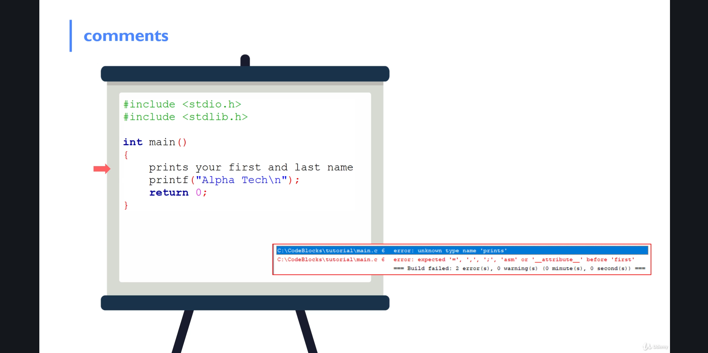

**Online coding:**

Problem 1: (using JAVA) program to find the Nth natural number with exactly two bits set.

